Inner salt pieces Nov. 7th 2017

Note: There are two sets of central columns (solid cylinders), pressing tubes, and brass pieces.

The columns with the large diameter are for the salt pieces around the sample, those with a smaller diameter are for the salt pieces around the pistons. Make sure to use the right combination of central column and pressing tube.

The calibration for how much salt you need to take and how long your salt piece will get is on the lab website (http://mpec.scripts.mit.edu/peclab/lab-calibrations-and-manuals/). Generally, you want to make a salt piece that is as long as possible so anything between 8-9 g salt is good.

First grind the salt with the espresso grinder until the crystals are crushed to a fine powder (the salt has lost its luster and it looks like powdered sugar). Store it in the oven if not pressed on the same day.

- Clean all the pressing pieces with water and soap and dry it. Use a little amount of soap to grease the central column and the pressing tube (Fig. 1).
- Insert the central column into the die.
- Mix a little distilled water (≈1/10 of spatula) with the salt and put the mixture in the die (make sure that the mixture is homogeneous).
- Use the pressing tube to pack the salt.
- Put the pressinge tube in the press die on top of the salt and the solid disc on top of the tube (Fig.1). and press carefully until 5 metric tons. Hold the pressure for several seconds, then open the valve to release the pressure.
- Put the complete assembly (central column, die, pressing tube, top disc) on the big steel ring and press carefully until the salt is out of the press die (take care that the ring and the central column do not touch the steel plates of the press). Pressing out the salt pieces usually produces some stick-slip and makes a loud noise (wear the ear protection if needed).

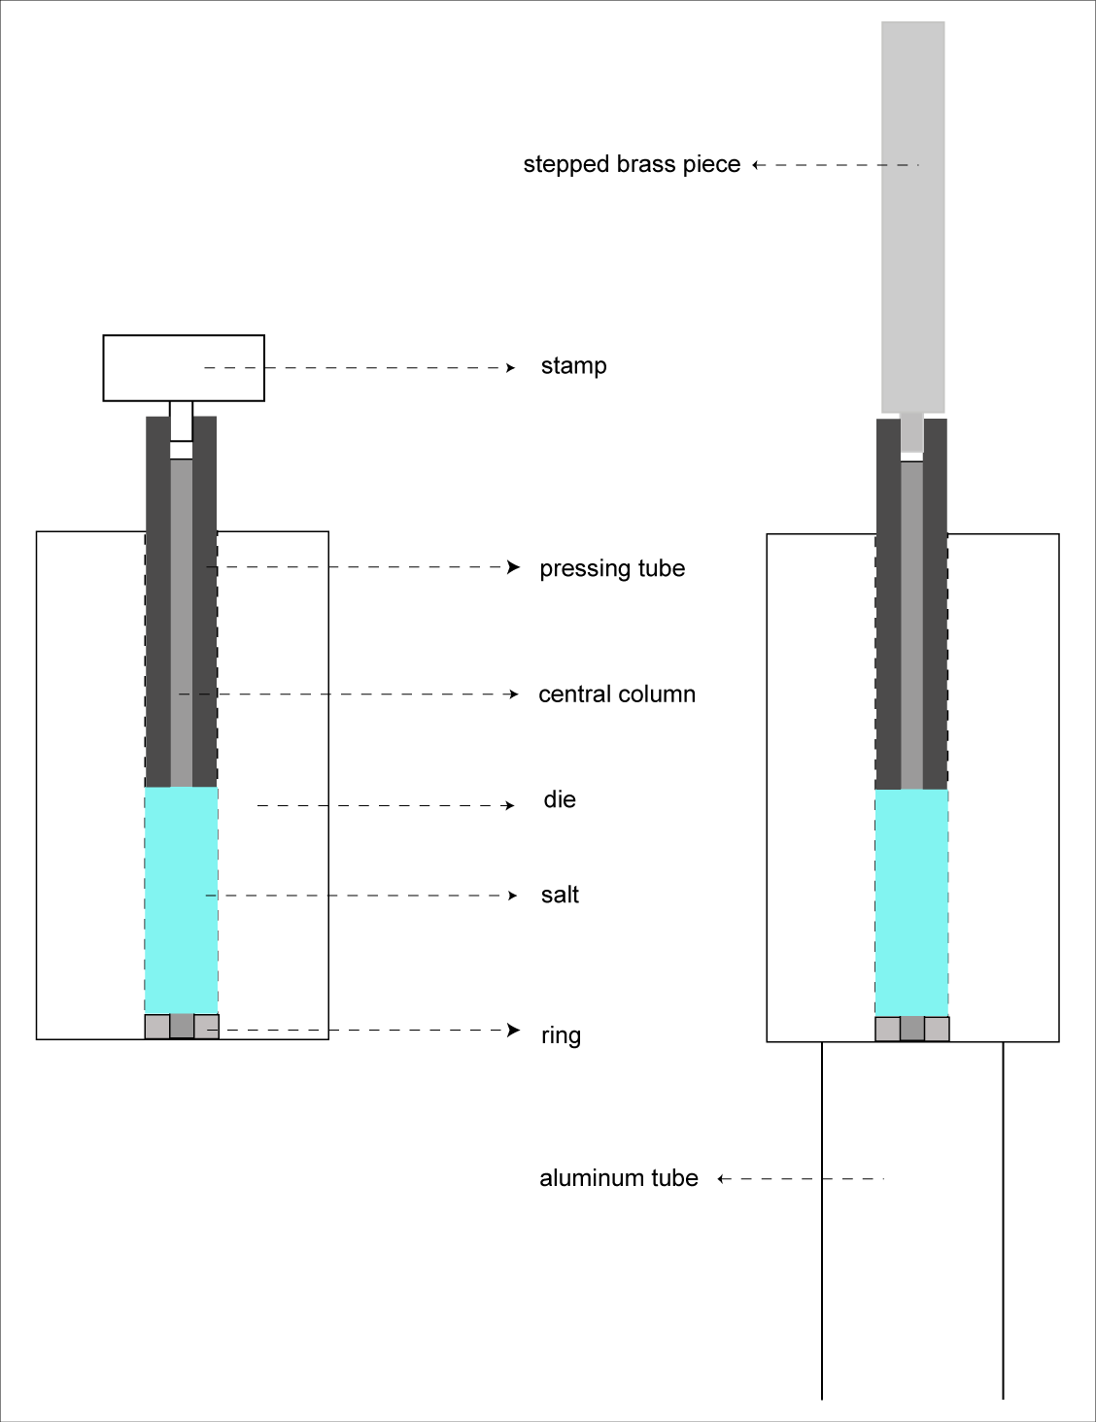
Fig.1: left: press die with salt, right: pressing assembly in the position to press the salt out

- Remove the big steel ring and the top disc: Put the die including the central column and pressing tube on top of the black metal plates
- Use the stepped brass piece (the one fitting to the pressing tube) to press the central column with salt and pressing tube out of the die. Continue pressing, until the central column falls down (catch it!). This should be easy.
- The salt can now be removed (by hand) from the central column. Dry and store it in the oven.
- Clean (with water and soap) and dry all pieces, which were in contact with the salt, and continue with a new salt piece.
- After all the work is done, clean carefully and oil all pieces before you put them away.

If the pressing tube still sticks to the central column:
Remove the die and the stepped brass piece. Put the iron metal strip (flat side up) on top of the aluminum tube. If salt and central column stick together, so that the metal plate cannot be placed: use your fingers to separate them a bit from each other and place the central column in the fitting groove in the strip in such a way that the metal is between the pressing tube and the salt. Than use the thin brass piece to press the column softly out of the pressing tube.

